BEANSTALK
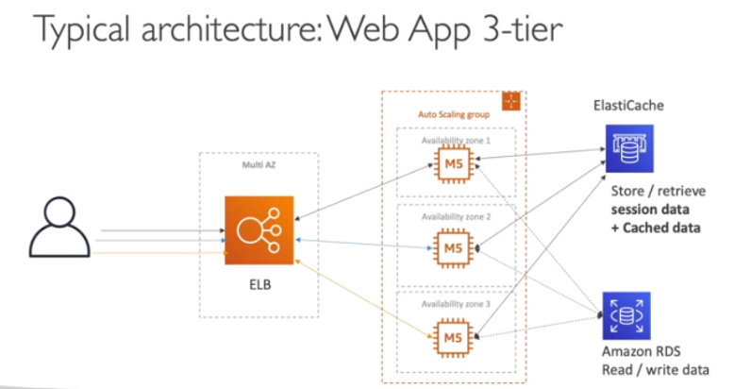

- Elastic beanstalk is a developer centric view of developing an application on AWS
- It used the components – ASG, EC2, ELB, RDS, etc.
- But, it’s an all-in-one view that’s easy to make sense of
- We still have full configuration
- Beanstalk is a Platform as a Service (PaaS)
- Beanstalk is free but using the underlying infrastructure is paid

ELASTIC BEANSTALK:
- It is a Managed service
- Instance configuration/OS is handled by Beanstalk
- Deployment strategy is configurable but it is performed by Elastic Beanstalk
- Capacity provisioning is done by Beanstalk
- Load balancing and auto-scaling is also done by Beanstalk
- Application health-monitoring and responsiveness is also available in beanstalk dashboard
- The developers just need to focus on the application code
- Three architecture models:
- Single instance deployment: good for dev
- LB + ASGs: great for production or pre-production web applications
- ASG only: great for non-web apps in production

Elastic Beanstalk supports many platforms:
- Go
- Java SE/Java with tomcat
- .NET on Windows server with IIS
- Node.js
- PHP
- Python
- Ruby
- Packer Builder
- Single/Multi/Preconfigured-container docker
- If anything is not supported, you can write your own custom platform (advanced)

Elastic Beanstalk – Health Monitoring
- Health agent pushes metrics to CloudWatch
- Checks for app health, publishes health events

